Tasks
Learners have to develop a dashboard to support the answers to the following questions.

Objective Questions:

1.What is the total no. of attributes present in the data? - Totally 15 attributes.
Tickets Tab : 10 attributes.
IT Agents Tab : 5 attributes.
2. Which columns have inconsistent or missing values, and what is the count of such values?
I identified and handled the following discrepancies in the dataset to ensure consistency:

- Spelling errors in the "Severity" column:
"3-Mayor" was corrected to "3-Major."
"0-Unclasified" was corrected to "0-Unclassified."
Handling: Each entry was manually reviewed and standardized to align with predefined categories for accurate data analysis.
- Spelling errors in the "Priority" column:
"0-Unassiged" was corrected to "0-Unassigned."
Handling: Values were cross-checked with standard priority categories to ensure no misspellings or inconsistencies remained.
- Column name standardization:
The column "Fecha" was renamed to "Ticket Date" to maintain consistency with other column names in English.
Handling: This change was made for clarity and to improve data readability.
In total, three columns (Severity, Priority, and Ticket Date) were found to have inconsistencies. These were corrected through spelling adjustments and column name standardization. Missing values were addressed by reviewing each column, though no additional missing values were reported beyond the above adjustments.

3. What is the average daily ticket volume over time?
Overall average ticket volume is 53 tickets.
Visualisation:
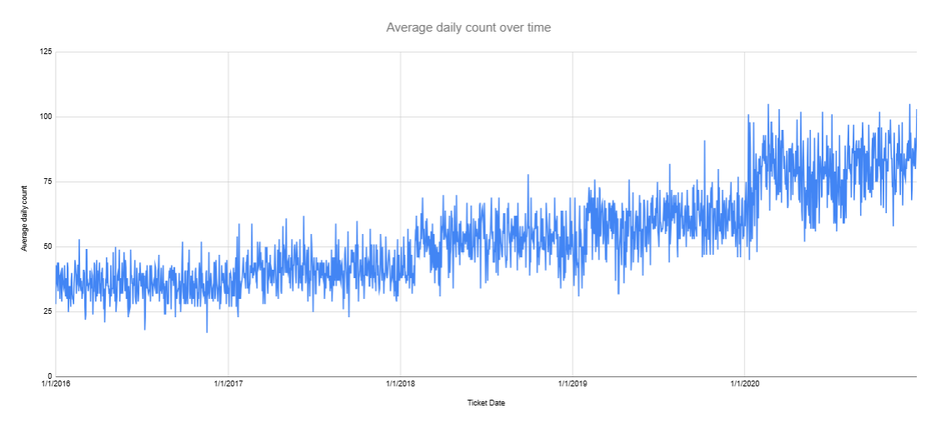
Observations:
- Overall Trend: There is a noticeable increase in the daily average ticket count over the displayed period. This suggests either an increase in the volume of issues reported or a growth in the scope or coverage of support services over time.
- Seasonal or Periodic Spikes: Some periods show sharp spikes, indicating sudden surges in ticket volumes. This could be due to new software or hardware rollouts, company-wide changes, incidents, or other events causing a temporary increase in issues reported.

- Gradual Growth: The increasing trend also indicates potential factors like customer or employee base growth, increased dependence on IT systems, or changes in service offerings driving up support needs.

- Stability and Fluctuation: While there is overall growth, the day-to-day values still exhibit significant fluctuations, suggesting variation in daily demand, which may challenge resource planning and staffing.

- What is the distribution of ticket categories (e.g., Login Access, System, Software)?
Visualisation :
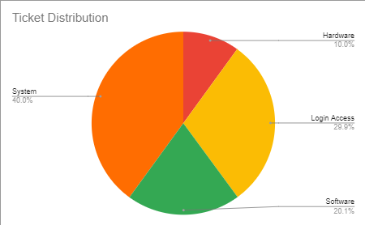
Observations:
- System Dominance: System tickets account for the largest portion of the ticket volume, representing 40% of all tickets. This suggests that issues related to the system infrastructure or software are the most common.
- Hardware and Software Requests: Hardware and software requests constitute a significant portion of the ticket volume, with 10% and 20.1% respectively. This indicates a consistent demand for support in these areas.
- Login Access: While representing a smaller percentage (29.9%), login access issues still constitute a notable portion of the ticket volume, suggesting that authentication and authorization problems are a recurring concern.

- How many tickets has each agent handled?
Visualisation table :
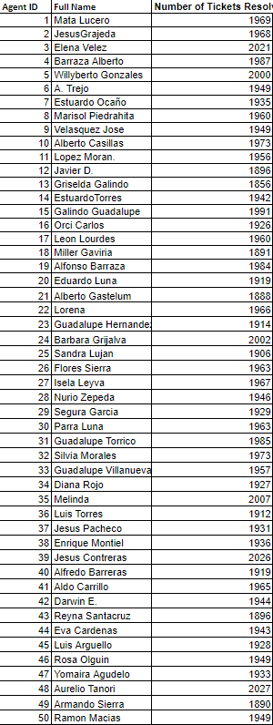
Observations:
1.Agent ID Range: The data includes agent IDs from 1 to 50, suggesting a relatively small team.
2.Ticket Resolution Volume: The number of tickets resolved varies significantly among agents, ranging from 1856 to 2027.
3.The agent with ID 48 resolved the maximum number of tickets (2027), while the agent with ID 13 resolved the minimum number of tickets (1856).
- How can you extract the domain from the email addresses in the IT Agents sheet?
Formula Components:
=REGEXEXTRACT(C2, "@([^.]+)") [ C2 has email addresses ]
- REGEXEXTRACT:
  - This function extracts a specific text from a string based on a regular expression pattern.
  - Syntax: REGEXEXTRACT(text, regular_expression)
- C2:
  - This is the input cell where the text you want to extract from is located.
- "@([^.]+)":
  - This is the regular expression pattern used to define what portion of text to extract. Here's how it works:
    - @: This matches the @ character in the text.
    - ([^.]+): This is a capturing group (denoted by the parentheses ()), and it defines what to extract:
      - [^.]: This is a negated character set, meaning it matches any character except for the period (.).
      - +: This quantifier matches one or more of the preceding characters (i.e., any character except .).

What It Does:
- The formula looks for an @ character in the text within cell C2.
- Once it finds an @, it captures and extracts all characters that follow it up until it encounters a . (dot). It does not include the . or any characters beyond it.

Example:
- If C2 contains hello@example.com, the formula would:
  - Find the @ symbol.
  - Extract all characters after the @ up to but not including the first ..
  - Result: example

In summary, this formula finds the position of the "@" symbol in the email address, then extracts the substring starting from the character after the "@" until the end of the string, effectively isolating the domain name.

7. How can you find the full name of an agent given their Agent ID?
Breaking Down the Formula:
=VLOOKUP(F2,'IT Agents'!$A$2:$B$51,2,FALSE)
This formula is using the VLOOKUP function to retrieve data from another sheet named "IT Agents." Let's analyze each part:
- F2: This refers to the cell F2 in the current sheet. It's likely the cell containing the value you want to search for in the "IT Agents" sheet.
- 'IT Agents'!$A$2:$B$51: This specifies the range of cells in the "IT Agents" sheet where you want to search for the value in F2.
  - 'IT Agents'!: Indicates that you're referencing a sheet named "IT Agents."
  - $A$2:$B$51: Defines the range of cells to search within. This means the formula will look in column A and column B, starting from row 2 to row 51.
- 2: This argument indicates the column index within the specified range from which you want to retrieve the value. Since you're searching in columns A and B, and you want to retrieve the value from the second column (column B), you specify 2.
- FALSE: This argument determines whether the lookup should be exact or approximate. In this case, using FALSE means that the lookup will find an exact match for the value in F2 within column A of the "IT Agents" sheet. If an exact match is not found, the formula will return an error.
8. What is the count of each issue type (e.g., IT Error, IT Request)?
The count of tickets each issue type is
IT Error | 24,274
IT Request | 73,219
Visualisation:
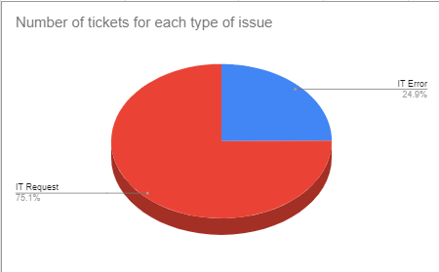
Observations:
- Dominance of IT Requests: The majority of tickets (75.1%) fall under the category of "IT Request," indicating that a significant portion of customer or employee interactions with the IT department are related to service requests or inquiries.
- Smaller Proportion of IT Errors: "IT Error" tickets constitute a smaller percentage (24.9%) of the total tickets. This suggests that while errors do occur, they are less frequent compared to service requests.

9 .What is the daily average resolution time for tickets?
Overall average resolution time is 5 days using the formula.
Visualisation of daily average resolution time for tickets :
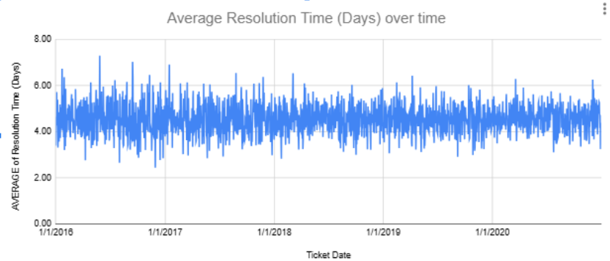
Observations:

- Relative Stability in Resolution Time: The average resolution time appears relatively stable throughout the displayed period, generally fluctuating between approximately 3 to 7 days. This suggests a consistent approach to daily ticket handling over time.

- Minor Peaks and Variations: Although there is overall stability, some noticeable spikes indicate periods where ticket resolution times were longer. These may coincide with high ticket volumes, complex issues, resource constraints, or other operational challenges.

- No Clear Downward Trend: There is no visible consistent downward trend, suggesting that the organization's efforts have not led to a notable reduction in average resolution time over the observed period.

10. How has the volume of tickets changed over time?
Visualisation :
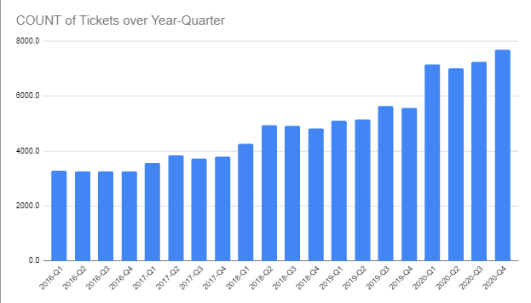
Observations:
There's a clear upward trend in the number of tickets issued over the years. This suggests increasing demand or usage of the service or product associated with the tickets.
- Seasonal Patterns: There appear to be seasonal fluctuations within each year. The ticket count tends to rise in the later quarters (Q3 and Q4) and then decline in the early quarters (Q1 and Q2). This might indicate seasonal factors influencing demand.
- Growth Rate: The growth rate seems to have accelerated in recent years. The increase in ticket count between 2018-Q4 and 2019-Q1, for example, is more significant compared to earlier periods.
- Outliers: There are a few data points that deviate from the general trend. For instance, the ticket count for 2016-Q1 is relatively low compared to the surrounding quarters.

11. What is the average age of the IT agents?
The formula =DATEDIF(DATE(E2, F2, G2), TODAY(),"Y") calculates the difference between a given date and the current date in years. Let's break it down:
- DATE(E2, F2, G2):
  - This part creates a date using the values in cells E2, F2, and G2.
  - E2 likely represents the year, F2 the month, and G2 the day.
- TODAY():
  - This function returns the current date.
- DATEDIF(date1, date2, unit):
  - This function calculates the difference between two dates in a specified unit.
  - date1 is the starting date, which is the date created in the first part of the formula.
  - date2 is the ending date, which is the current date obtained using TODAY().
  - unit specifies the unit of measurement for the difference. In this case, "Y" indicates years.
Therefore, the entire formula calculates the number of years that have elapsed between the date specified in cells E2, F2, and G2 and the current date.
Formula used to calculate the average age of the IT agents :
=AVERAGE(H2:H51) where column H represents the ‘Age’ column.
The average age of the agents is 39 years.

12. Is there a correlation between the severity of issues and the resolution time?
Correlation formula : =CORREL(severity_range, resolution_time_range)
Formula you can find in Agents tab : =CORREL(H2:H97499,J2:J97499)
Observation :

Interpretation of CORREL Function between the severity of issues and the resolution time results (-0.04053634915)
A correlation coefficient of -0.04053634915 indicates a very weak negative correlation between issue severity and resolution time.
This means that there is almost no relationship between the severity of an issue and the time it takes to resolve it.

13. How many categorical columns are there in the data? [Search about categorical and continuous data, and try to answer this question]
There are about 9 categorical columns.
Tickets Tab :
- Request Category (e.g., Hardware, Software, Login Access, System)
- Issue Type (e.g., IT Error, IT Agent)
- Severity (0-unclassified, 1-Minor, 2-Normal, 3-Major, 4-Urgent)
- Priority (0-Unassigned, 1-Low, 2-Mid, 3-High)
- Satisfaction Rate (1, 2, 3, 4, 5)

Agents Tab :
- Full Name
- Domain (the area of expertise or department)
- Month of Birth
- Age (considered categorical if grouped)

Subjective Question:

- If there is an investment, should it be used to hire more IT agents, improve training programs, or upgrade ticket management software?
Analysis: Perform a cost-benefit analysis using ticket resolution and satisfaction metrics.
1. Hiring Additional IT Agents
Visualization :
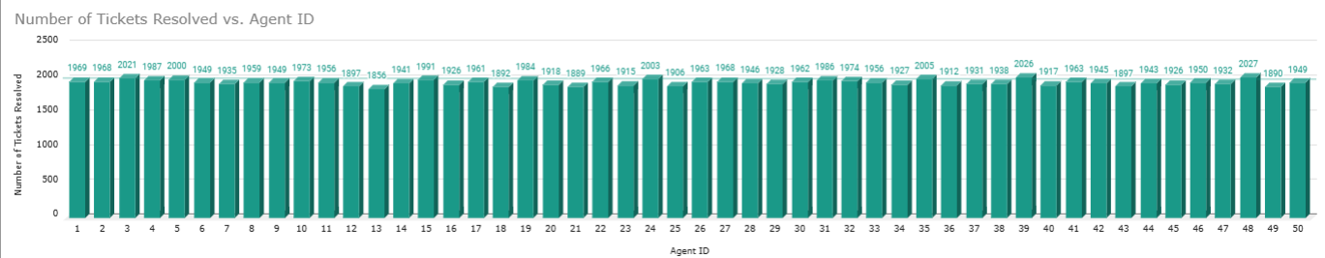

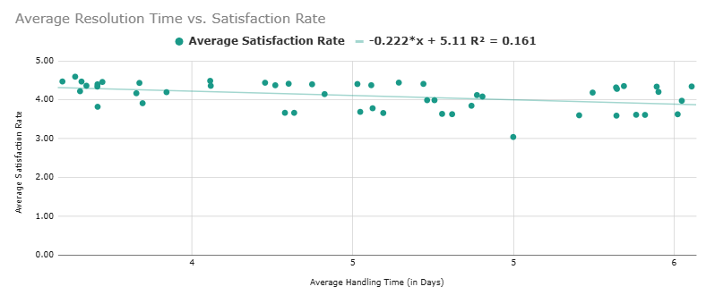
Observation :
- An R - Square value of 0.161 (or 16.1%) in the scatter plot indicates a weak correlation between Average Resolution Time and Satisfaction Rate per Agent.

- Since the R- square value is relatively low, it indicates that improving resolution times (by hiring more agents) may not have a strong or predictable impact on customer satisfaction.

Costs of hiring new agents :
Hiring new agents involves costs related to recruitment, salaries, benefits, and workspace (or remote setup). Additionally, training new hires requires time and resources.

2. Improving Training Programs
Visualization :
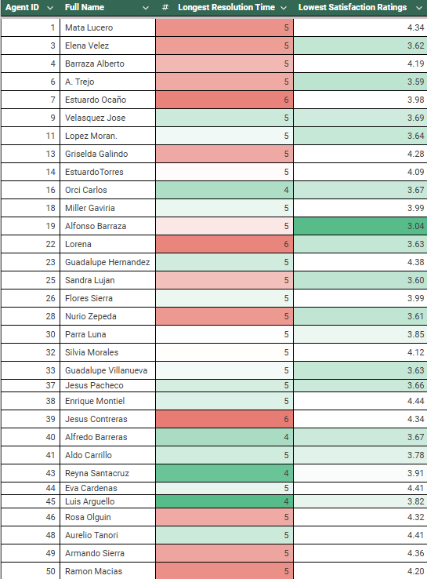
Observation:
- Agents with longer resolution times tend to have lower satisfaction ratings, there is a clear pattern indicating a need for skill development and better ticket management practices.

- Training Focus: Agents with lower satisfaction and higher resolution times should be prioritized for targeted skill development, focusing on reducing resolution times through better workflows, technical skills, or customer interaction strategies.
The visualization suggests that there is often a correlation between longer resolution times and lower satisfaction ratings. Addressing these issues with targeted training and process improvements for agents showing these metrics can likely improve overall customer satisfaction and efficiency.
Costs:
Training program costs may include content creation, specialized trainers, and time away from daily tasks. However, this cost is usually lower than hiring additional agents or implementing new software.

3. Upgrading Ticket Management Software :
Visualization :
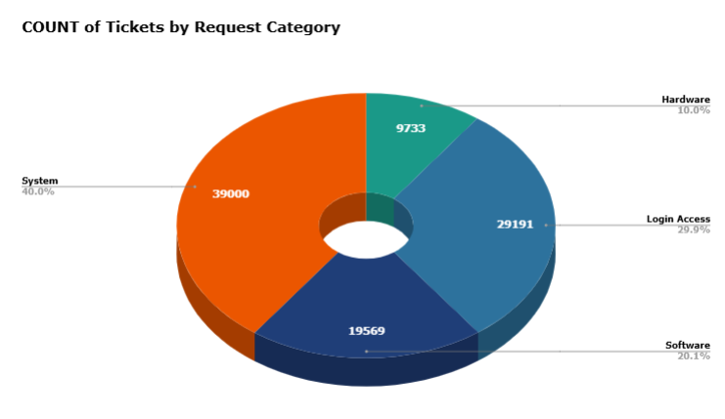
Average Resolution Time for Software-Related Requests (in Days) - 5 days.
Average Resolution Time for Other Requests (in Days) - 4 days
Observation:
Let's assume there are 1,000 total tickets per month:
- 26.5% corresponds to 265 software-related tickets.
- A reduction in resolution time by 1 day (e.g., from 5 days to 4 days) for these 265 tickets saves 265 days of resolution effort over a month.
- The value of those saved days can be quantified based on agent cost, productivity gains, or improved service levels.
Costs:
Upgrading ticket management software can be one of the most expensive options due to software licenses, transition time, and potential downtime during the switch.

My justification :
To enhance agent performance and improve customer satisfaction and resolution rates, investing in comprehensive training programs is recommended. Such programs may incur costs for content development, specialized trainers, and employee training time. However, these initial investments are generally less substantial than the costs associated with hiring additional staff or implementing new software solutions.

- Which agents need additional training based on their performance metrics?
Analysis: Identify agents with the lowest satisfaction ratings and longest resolution times.
Visualisation :
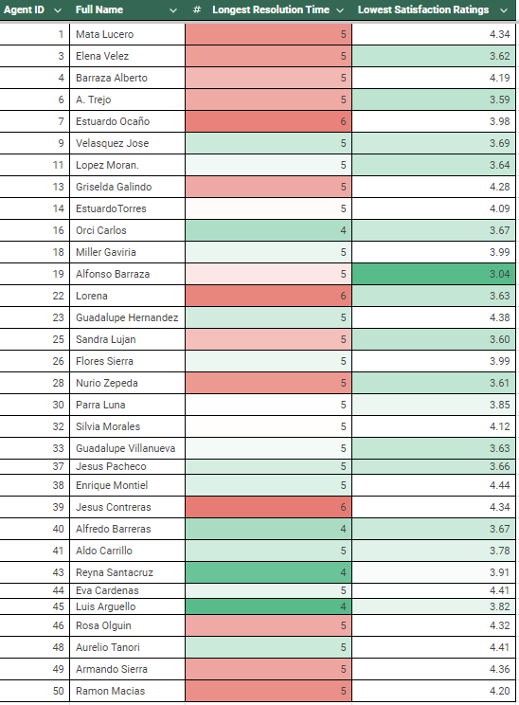

Insights :
• Longest Resolution Time: All agents have a longest resolution time of 5, indicating that there might be underlying factors influencing resolution times beyond individual agent performance.
• Lowest Satisfaction Ratings: The lowest satisfaction ratings range from 3. 04 to 4. 44, suggesting a relatively consistent level of customer satisfaction overall.
• Outliers: Agents 16 and 40 stand out with a longest resolution time of 4, which could be due to specific case complexities or external factors.
Recommendations:
- Investigate Underlying Factors:
  - Case Complexity: Analyze if specific types of tickets (e.g., hardware, software) are consistently taking longer to resolve. If so, consider investing in additional resources or training for those areas.
  - Workload Distribution: Examine if agents are overloaded with work, leading to longer resolution times. If so, consider rebalancing workloads or hiring additional agents.
  - System Constraints: Assess if limitations in the IT infrastructure or systems are contributing to delays. Upgrade hardware or software as needed.
- Focus on Customer Satisfaction:
  - Identify Trends: Analyze satisfaction ratings by agent and identify patterns or areas for improvement.
  - Provide Training: Train agents on customer service best practices and conflict resolution techniques.
  - Gather Feedback: Implement a system for collecting and addressing customer feedback.
- Optimize Processes:
  - Streamline Procedures: Review and streamline processes to reduce the time it takes to resolve tickets.
  - Knowledge Base: Develop a comprehensive knowledge base to help agents find solutions quickly.
  - Automation: Explore opportunities for automating routine tasks to free up agent time.
- Monitor and Measure:
  - Regular Reviews: Conduct regular performance reviews to assess agent performance and identify areas for improvement.
  - Key Performance Indicators (KPIs): Establish KPIs related to resolution time, satisfaction ratings, and other relevant metrics.

- Do certain categories of requests have longer resolution times?
Analysis: Analyze the resolution times by request category.
Visualisation :
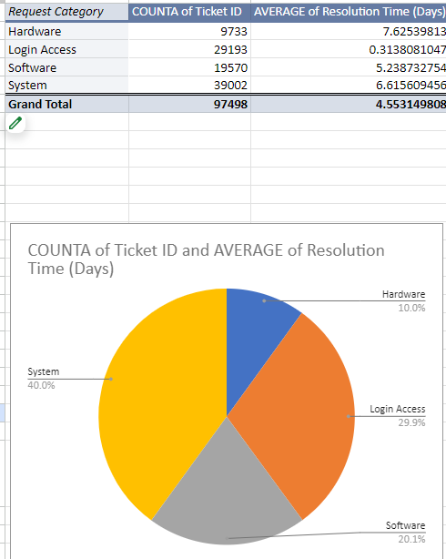
Insights :
We can conclude that certain categories of requests do have longer resolution times.
• Hardware has the highest average resolution time at 7.63 days.
• System has a longer average resolution time at 6.62 days.
• Software resolution time is close to the middle at 5.24 days.
• Login Access has the lowest average resolution time at 0.31 days.
• Possible reasons for differences include problem nature, resource availability, or specific processes.
Recommendations :
Analyze Root Causes: Investigate the underlying reasons for the high volume of System and Login Access tickets. Identifying common issues or patterns could help implement preventive measures to reduce the number of tickets in these categories.
Track Resolution Time Trends: Monitor changes in average resolution times over time to identify trends and assess the effectiveness of any improvements or interventions.
Prioritize Ticket Categories: Based on the volume of tickets and their average resolution times, consider prioritizing certain categories for faster resolution. For example, if Login Access issues are impacting a large number of users, they might require more immediate attention.

- How effective are the current software tools in managing IT tickets?
Analysis: Evaluate performance metrics before and after the implementation of new tools.
Visualisation of Priority contribution :
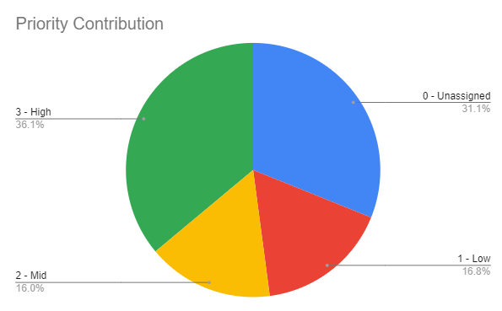
Insights:
- High Volume of Unassigned Tickets: A significant portion of tickets remain unassigned, indicating potential bottlenecks in the assignment process or insufficient resources.
- Priority Distribution: The distribution of tickets across different priorities is skewed towards lower priorities, suggesting that a majority of tickets are not considered urgent.
Recommendations:
- Address Unassigned Tickets: Investigate the reasons for the high volume of unassigned tickets and implement measures to streamline the assignment process and ensure timely allocation of resources.
- Prioritise High-Severity Tickets: Implement strategies to prioritise high-severity tickets and ensure they are addressed promptly. This could involve assigning dedicated resources or implementing escalation procedures.
- Evaluate Priority Assignments: Review the criteria used for assigning ticket priorities to ensure they accurately reflect the urgency of issues. Consider adjusting the criteria if necessary.

Visualisation of Severity contribution :
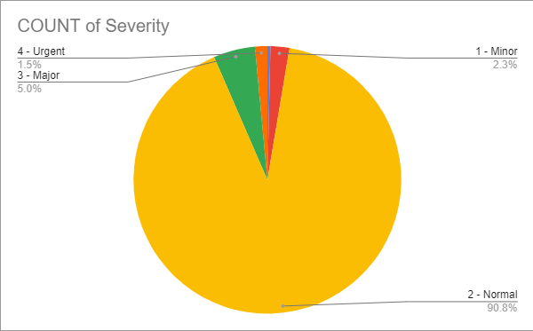
Insights:
- Overwhelming Majority of Normal Severity: The vast majority (90.8%) of tickets are classified as "Normal" severity. This suggests that a significant portion of issues are not considered urgent or critical.
- Minimal Urgent Tickets: Only 1.5% of tickets are classified as "Urgent," indicating that most issues are not perceived as requiring immediate attention.
Recommendations:
Optimise Normal Severity Ticket Handling: Develop strategies to efficiently handle the large volume of "Normal" severity tickets without compromising the resolution of more critical issues. This could involve process improvements, automation, or reallocating resources.
Prioritise Urgent Tickets: Ensure that "Urgent" tickets are addressed promptly to prevent potential disruptions or negative customer experiences. Implement escalation procedures and assign dedicated resources to these tickets.

- How has the performance of the IT support team changed over time (e.g., monthly or quarterly)?
Analysis: Trend analysis using time series charts.
IT Support Team performance analysis :
Visualisation:
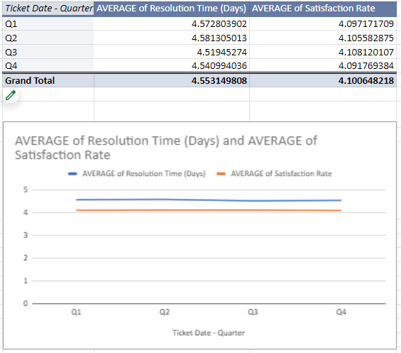
Insights :
- The satisfaction rate varies slightly throughout the year with no clear trend, indicating consistent performance.
- Quarter 2 had the highest resolution time, while Quarter 3 had the lowest.
- Quarter 2 and 3 had the highest satisfaction rates, while Quarter 4 had the lowest.
- There is no strong correlation between resolution time and satisfaction rate.
Recommendations:
1. Analyze Seasonal Factors:
Investigate if external factors (e.g., seasonal workload fluctuations, holidays) might be influencing performance in specific quarters.
2. Deep Dive into Quarter 2:
- Conduct a more in-depth analysis of Quarter 2 to understand why resolution times were higher despite high satisfaction rates.
- Identify specific cases or trends that contributed to the longer resolution times.
3. Optimise Processes in Quarter 4:
- Analyse why satisfaction rates were lower in Quarter 4 and identify areas for improvement.
- Consider implementing new processes or training to enhance customer satisfaction.
4. Explore Alternative Metrics:
- Since resolution time and satisfaction rate don't have a strong correlation, consider exploring other metrics (e.g., first call resolution, average handling time) that might provide a more complete picture of performance.
5. Continuous Improvement:
- Implement a continuous improvement framework to identify and address performance gaps throughout the year.
- Regularly review and update processes based on evolving needs and trends.

- If we invest more on tech (Hardware, software, etc), do you think it will improve the ticket resolution times and employee satisfaction?
Analysis: Use historical data to project potential improvements.
Category trend analysis using historical data :
Visualisation : 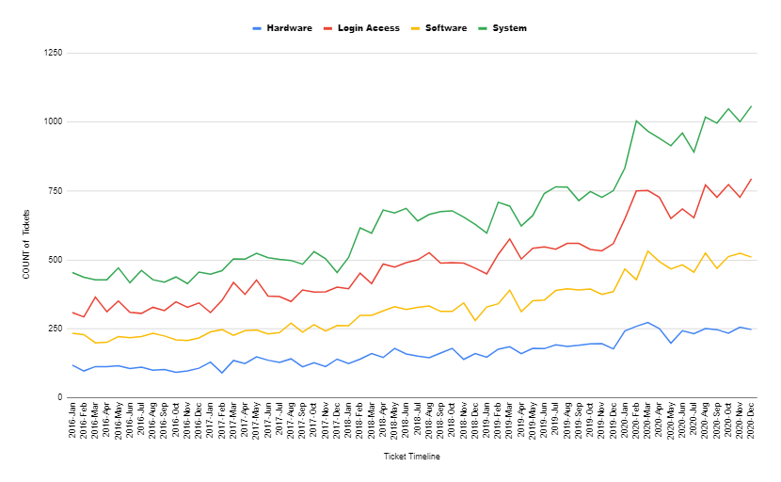
Insights:
- Consistent Demand for Hardware and Software: The ongoing demand for hardware and software support indicates a need for adequate resources and processes to address these categories effectively.
- Fluctuating Login Access: The varying number of login access tickets suggests that factors like security updates, policy changes, or user behaviour might influence the demand for assistance in this area.
- Increasing System Tickets: The gradual increase in system tickets might be attributed to changes in technology infrastructure, software updates, or growing complexity of IT systems.
Recommendations:
- Optimise Hardware and Software Support: Implement strategies to streamline processes, improve efficiency, and reduce resolution times for hardware and software tickets. This could involve automation, knowledge base development, or specialised training for agents.
- Monitor Login Access Trends: Keep track of fluctuations in login access tickets to identify potential security threats or user training needs. Consider implementing preventive measures or providing additional support to address these issues.
- Anticipate System Ticket Growth: As system tickets continue to increase, ensure that the IT team has the necessary resources and expertise to handle the growing demand. This might involve investing in additional staff, training, or technology.

- What are the key performance metrics for IT agents, and how can they be improved, do we need to fire any agents?
Analysis: Define and analyze metrics such as average handling time, satisfaction scores, and number of tickets resolved.
Key Performance metrics visualisation :
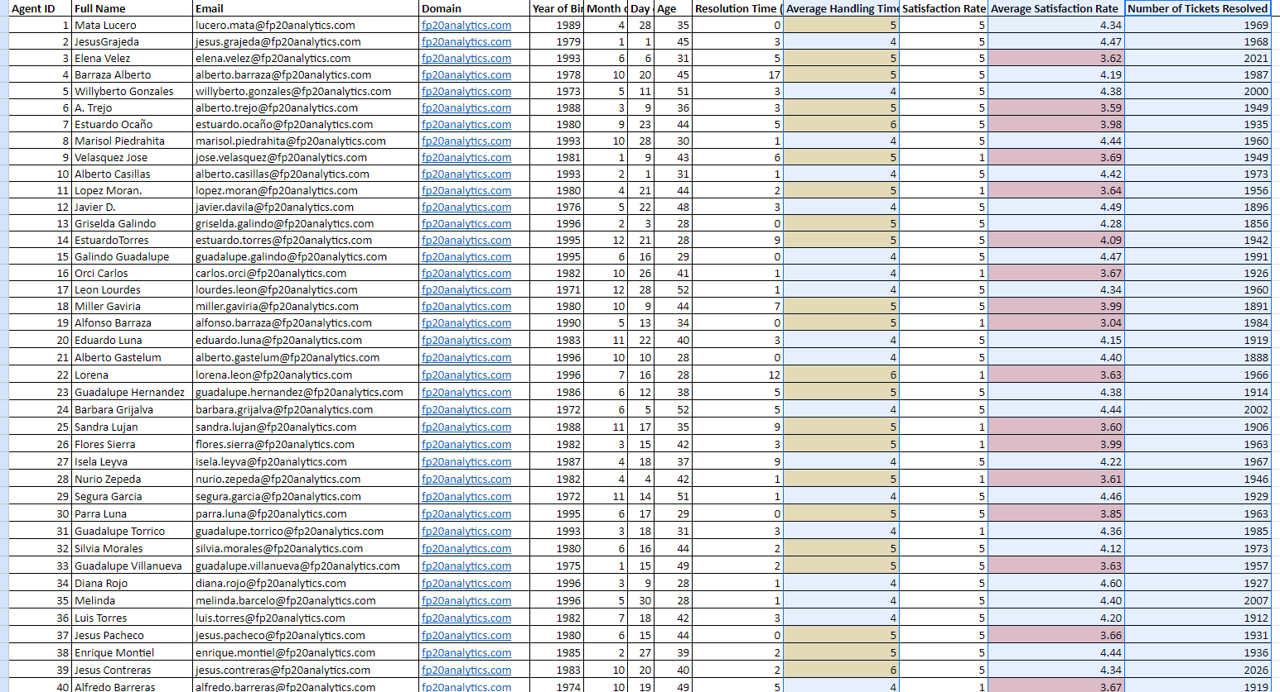
Insights :
Key performance metrics :
• Average Handling Time (AHT)
• Average Satisfaction Rate
• Number of Tickets Resolved.

Before Terminating Agents:

Data-Driven Decision Making includes ideas such as,

• Review performance over a sufficient time frame.
• Consider external factors impacting performance.
• Compare agents against benchmarks or averages.

Exit Strategies :

• Implement a performance improvement plan (PIP) for consistent underperformance.
• Monitor progress closely during the PIP period.
Recommendations :
- Employee Engagement: Foster a positive work environment and encourage employee engagement to improve overall performance.
- Technology Investments: Evaluate the need for new tools or technologies to enhance agent productivity and customer satisfaction.
- Regular Feedback: Provide regular feedback to agents, both positive and constructive, to help them improve their performance.

- How do employee demographics (e.g., department, seniority) impact satisfaction and ticket outcomes?
Analysis: Segment analysis using filters and pivot tables.
Department analysis :
Visualisation :
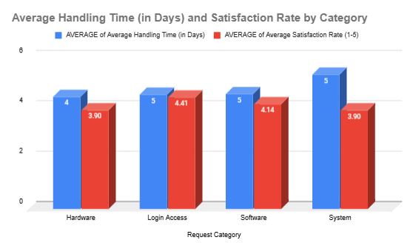

Insights:
- Hardware and Login Access: These categories have the highest average handling times, suggesting that they might require more complex resolution processes or involve specialized resources.
- Software and System: While having slightly lower handling times, these categories still have room for improvement, especially if they impact customer satisfaction.
Recommendations:
- Optimize Hardware and Login Access: Investigate the factors contributing to the longer handling times for hardware and login access requests. Identify opportunities for process improvement, resource allocation, or automation to reduce resolution times.
- Enhance Software and System Satisfaction: While handling times for software and system requests are relatively lower, analyze customer feedback to identify areas where satisfaction can be improved. Consider implementing additional training or providing more comprehensive support.
Seniority Analysis:
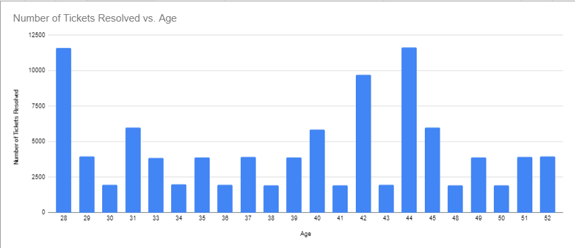
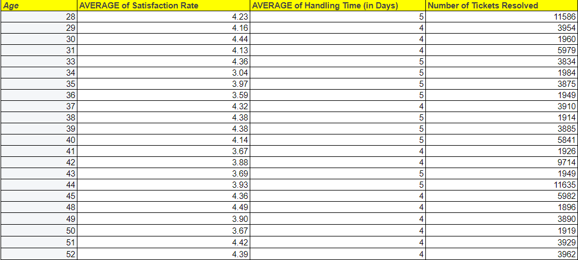
Insights :
Average Handling Time: The average handling time remains relatively consistent across different age groups, suggesting that age is not a significant factor in determining resolution times.
Satisfaction Ratings: There are slight variations in satisfaction ratings among different age groups, but these differences are not substantial enough to draw definitive conclusions.
Recommendations:
- Focus on Skill Development: Prioritize training and development programs to enhance agent skills and capabilities, regardless of age. This can help improve performance and reduce resolution times.
- Evaluate Performance Based on Metrics: Assess agent performance based on key metrics such as resolution times, satisfaction ratings, and productivity, rather than solely focusing on age.
- Identify Areas for Improvement: Analyze individual agent performance to identify areas where additional support or training might be beneficial. This could help address any performance gaps and improve overall team efficiency.

- Identify the trends for IT support operations based on ticket volumes and satisfaction, and mention the peak and stable times?
- Analysis: Use pivot tables and charts to identify peak and off-peak hours.
Tickets volume Visualisation :
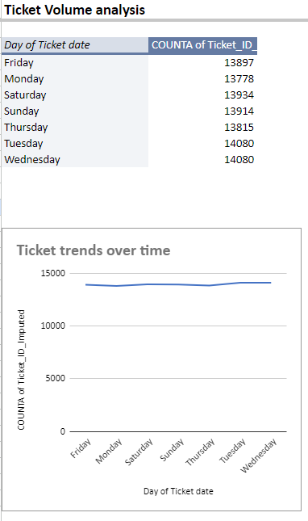
Insights :
> Highest Volume on Tuesday and Wednesday: The highest number of tickets are created on Tuesdays and Wednesdays.
> Lowest Volume on Friday: The lowest number of tickets are created on Fridays.
> Relatively Consistent Volume: Ticket volume is relatively consistent throughout the rest of the week (Monday, Saturday, Sunday, Thursday).
> Weekend Trend: There's a slight trend of higher ticket volume on weekends (Saturday and Sunday) compared to weekdays.
Recommendations:
Staffing: Increase staffing on Tuesdays and Wednesdays to handle the higher volume.
Automation: Explore automating routine tasks on Fridays to reduce workload.

Proactive Support: Consider offering proactive support on weekends to address potential issues before they escalate.
Analyze Peak Times: Identify specific time periods within Tuesdays and Wednesdays with the highest volume and schedule staff accordingly.
Satisfaction Rate Visualisation :
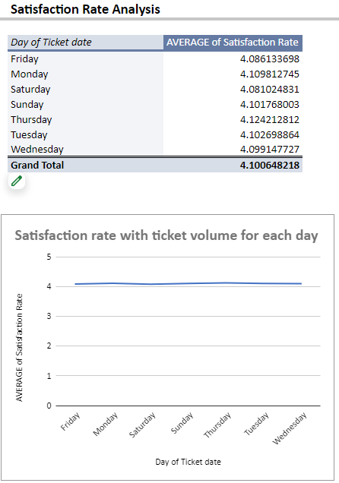
Insights :
> Highest Satisfaction on Thursday: Tickets created on Thursdays have the highest average satisfaction rate.
> Lowest Satisfaction on Friday: Tickets created on Fridays have the lowest average satisfaction rate.

> Relatively Consistent Satisfaction: Satisfaction rates for tickets created on Monday, Tuesday, Wednesday, Saturday, and Sunday are relatively consistent, with minor variations.
> Weekend Trend: There's a slight trend of higher satisfaction rates on weekends (Saturday and Sunday) compared to weekdays.
Recommendations :
Prioritise Thursday Tickets: Given the higher satisfaction on Thursdays, consider allocating more resources or focusing on improving processes for tickets created on this day.
Address Friday Issues: Investigate the reasons for lower satisfaction on Fridays. Are there specific issues or workload factors contributing to this? Implement strategies to improve performance on this day.

Maintain Consistency: While satisfaction is relatively consistent on most days, identify any minor variations and address them to ensure a consistently high level of service.

Leverage Weekend Trend: Capitalise on the slightly higher satisfaction on weekends by optimising staffing or processes to maintain or improve this trend.

- What metrics should be included in the final dashboard to provide a comprehensive view of call centre performance and guide investment decisions?
To create a comprehensive dashboard for the IT Ticket analysis project, it’s essential to include metrics that provide insights into performance, efficiency, and customer satisfaction.

The following are important factors to consider:

Ticket Metrics:
Total Tickets: Count of tickets received over a specified period.
Average Resolution Time: Average time taken to resolve tickets (in days). Average Resolution Rate: Percentage of tickets resolved compared to the total tickets received.

Satisfaction Metrics :

Average Satisfaction Rate: Average satisfaction score from resolved tickets.
Satisfaction Rate Distribution: Breakdown of satisfaction scores (1 to 5) to visualise customer sentiment.

Agent Performance Metrics :
Average Handling Time: Average time agents spend resolving tickets.
Tickets Resolved per Agent: Number of tickets each agent resolves in a specific period.
Agent Satisfaction Rate: Average satisfaction score received for each agent, if applicable.

Request Category Metrics:
Tickets Category: Breakdown of tickets by request category (Hardware, Software, Login Access, System) to identify trends.
Average Resolution Time by Category: Understanding which categories take longer to resolve can guide resource allocation.

Severity and Priority Metrics:
Tickets by Severity Level: Number of tickets categorized by severity (Urgent, Major, etc. ) to assess impact on service.
Average Resolution Time by Severity: Helps to understand how quickly critical issues are addressed.

Time-Based Trends Monthly/Quarterly Trends:
Line charts showing trends in ticket volume, resolution times, and satisfaction rates over time to identify patterns and seasonality.
Peak Times: Identify peak times for ticket volume to optimize staffing and resources.

Cost-Benefit Analysis (for Investment Decisions) :
Cost per Ticket: Average cost associated with resolving a ticket.
Projected Savings from Investments: Estimated savings from proposed technology investments based on historical improvements in resolution times and satisfaction rates.

Ensure that you put the slicers for choosing the priority wise and year in order to observe the dashboard since the management will be having a long discussion which can go for weeks.

Note: The dashboard would be more interactive and user-friendly, allowing management to explore data in detail and make informed decisions.

